Sara Ahmed Abd El-Latif Abd El-Allha

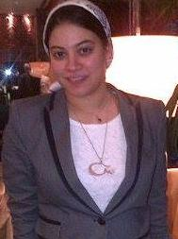
Name : Sara Ahmed Abd El-Latif Abd EL Allha
Address : 14 Abo dawoud st , Nasr city
Home Tel : 02-22748401
Mobile : 02- 01000557229 /02- 01202088020
Email : academic.international88@gmail.com
Birth Date : 03 March 1988
Marital Status : single
Religion : Muslim
Education
- Pre Master Degree At the Faculty of Mass Communication – English Section - Cairo university , 2010
- Marketing and Public Relation Diploma at American Chamber of Commerce ,2014
Faculty of Mass Communications, English Section “MCUC”

Year of graduate : 2008-2009
Degree : Excellent with honor
BA of Mass communication, public relation and advertising department, The First Class Of English Section 2005 (mcuc), Cairo University.

Work Experience:-

Working at The United Bank of Egypt (From September, 2009 till present)
My Job Title: - External Communication Senior specialist at corporate and internal communication Department.
My Current Experience: Five years in Field of Corporate Communication and Public affairs.
My Work Responsibilities and Main Duties at the United Bank of Egypt:
- I’m Totally Responsible for External Communication Dealing with Journalism and Press Media Publications.
- Creating Competitive Media Reports through media monitoring on Monthly /Quarterly and yearly basis.
- Responsible for the United Bank public official website data entry /editing and publishing.
- Following up with Advertising Agencies on Daily basis on various media campaigns and media booking.
- Conducting Monthly Advertising product plan in coordination with Retail Department.
- Setting product Media Plans on yearly Basis.
- External Events Organization and Media Booking .
- Main Responsible for Digital Media campaigns through operation of United Bank Social Media Channels.
- Writing and executing external announcements and newsletters .
- Checking with Branches the availability of printing materials , Flyers , ATM Screens Updates.
- Contribution in internal Media Campaigns for united Bank Staff.
- Conducting annual Survey’s to measure Client’s/ Customer satisfaction .

Working at The American university of Cairo - Greek Campus “part time basis”
- Working as community digital marketing specialist in various projects handled by CSworx company in the Digital Social Media Marketing locally and Globally on part time basis .
Social Media pages that I managed on Facebook :
- The United Bank of Egypt “ I created the page and I manage everything up till present “
- CADCAMSIM Company
- Busma security solutions
- El Juhani for Exporting and Importing Fruits and Vegetables
Social Media pages that I managed on LinkedIn:
- The United Bank of Egypt official LinkedIn page
- El Juhani for Exporting and Importing Fruits and Vegetables

Also, I have background on how to manage pages using Twitter and Instagram

My Previous Work Experience:
- Worked for a while as An English instructor in An international school (Els British &American school) in 1st of Jan,2009 Till August 2009 .
- Participated in public speaking lectures and workshops as a part of youth leadership initiative (Alashanek ya balady in association with Vodafone) .
- Attend a Business communication seminar in the Canadian Training Center of human Development (CTCHD) .
- Training in Al-Ahram weekly for one month (2008).
- Training in letters of credit Department at Barclays Bank Egypt for one month (2006).
- Training at Barclays bank Egypt’s corporate Banking Division for one month (2008).
- English course in The British council advanced level conversation program.
My Graduation Projects:
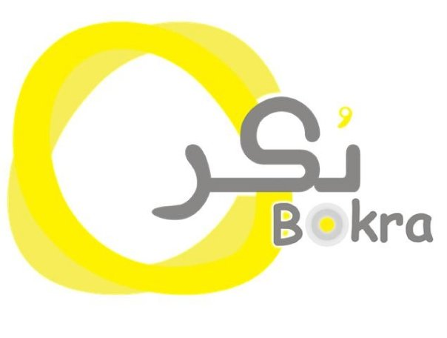
- Earf social marketing campaign Targeted for youth (market research – TV ads –radio tips -out doors -printed materials (brochures-booklet-special events) - internet activities (designing a website)) “Graduation project”
- Bokra Marketing campaign at the faculty of Mass communication Cairo University Model wining the best Marketing project

Language Skills

Arabic : Mother tongue
English : excellent spoken, reading and written (Toefl with degree 550)
French : good
Computer Skills
Adobe Programs ( Photoshop – Illustrator – InDesign )
Excellent Skills in Microsoft Office.
Excellent Internet Skills.
Good Knowledge about Local Area Network.
Good Knowledge about operating systems & troubleshooting.
Personal Skills

- Self motivated to work.
- High ability to develop and add value to work area.
- High ability to work individually and in team work.
- High ability to bear responsibility.
- Curious to increase business knowledge and experience.
- Can work cooperatively with different groups to achieve optimum objectives, active and enjoying team work, can work under pressure.
Interests
- I am fascinated by marketing and advertising field.
- Watching different advertisements and analyzing them.
- Creating slogans and developing advertisements ideas.
- Studying the market and doing research about different products to see the top brands and what they did to be no .1 in consumers.

“References and letters of recommendation available on request”

